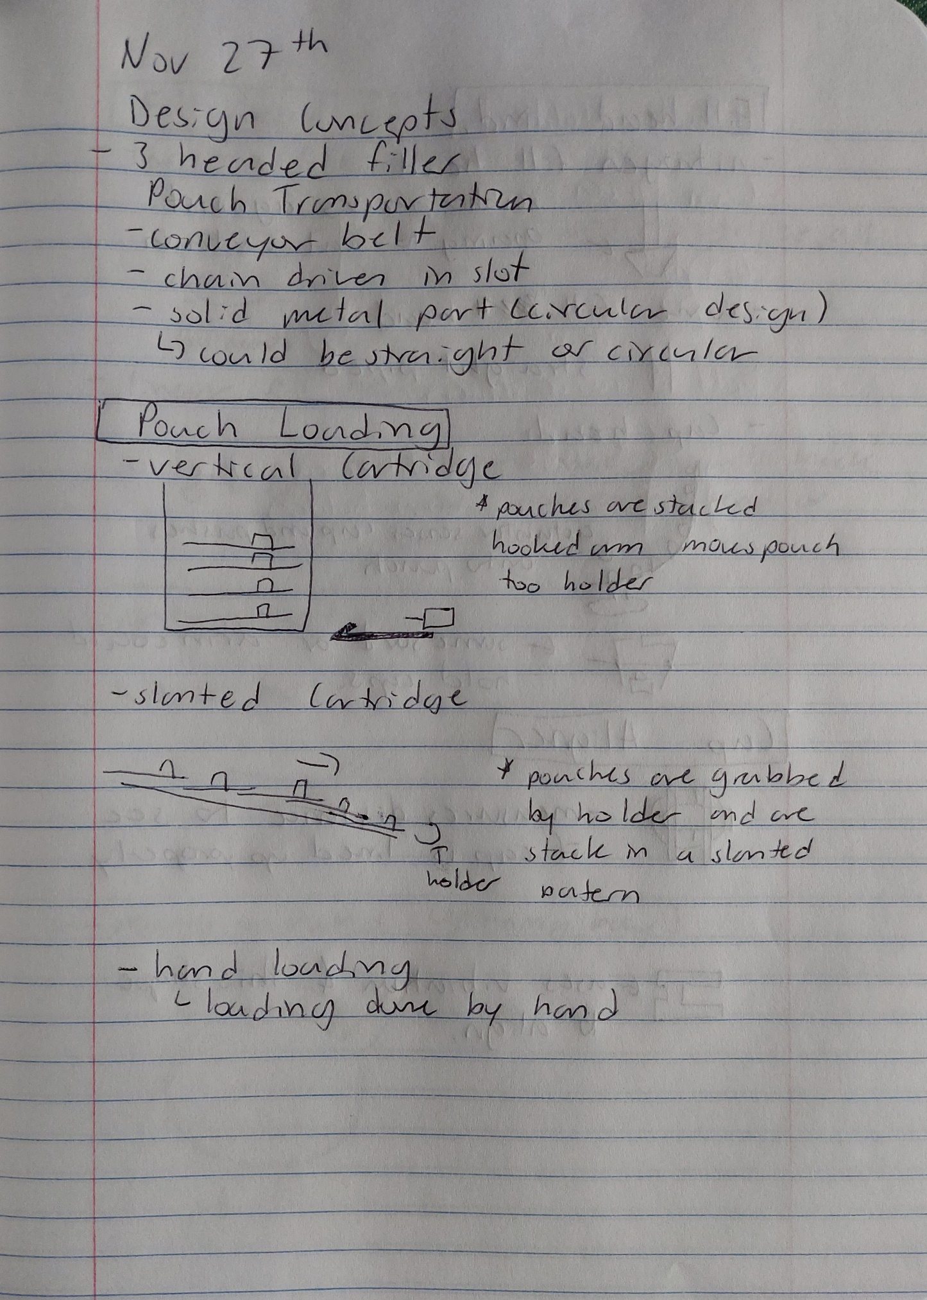

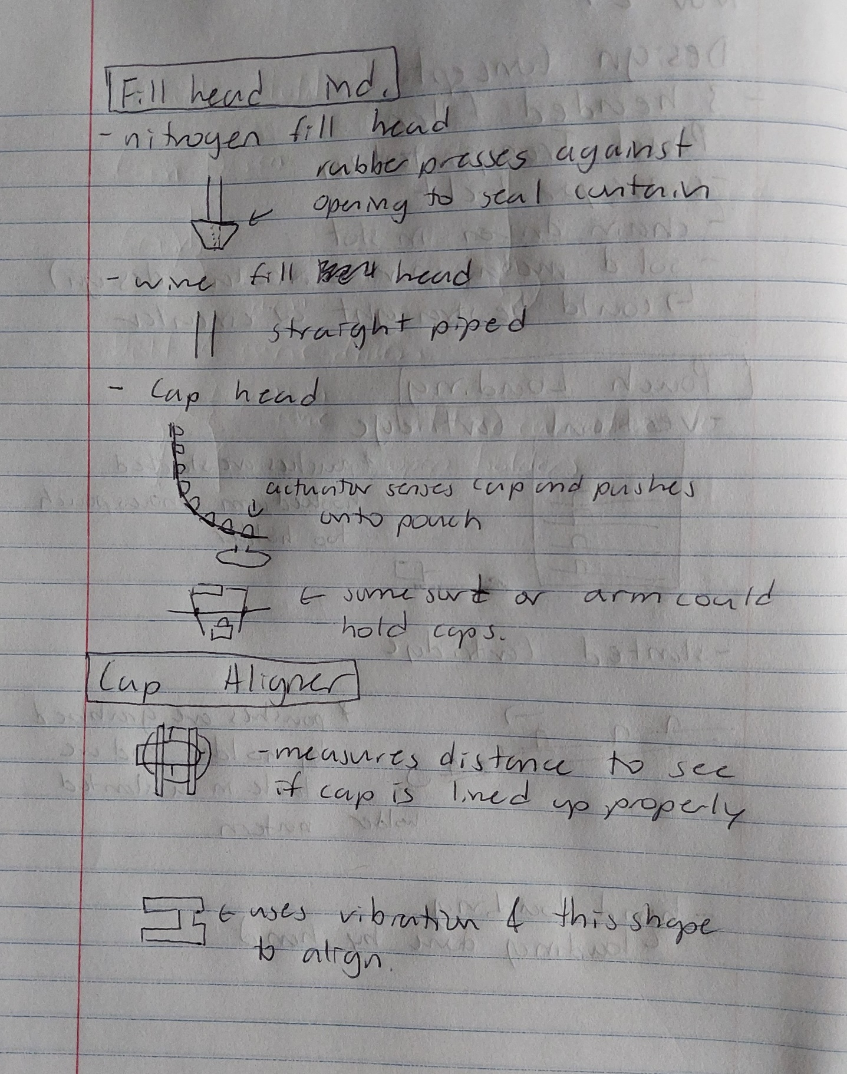

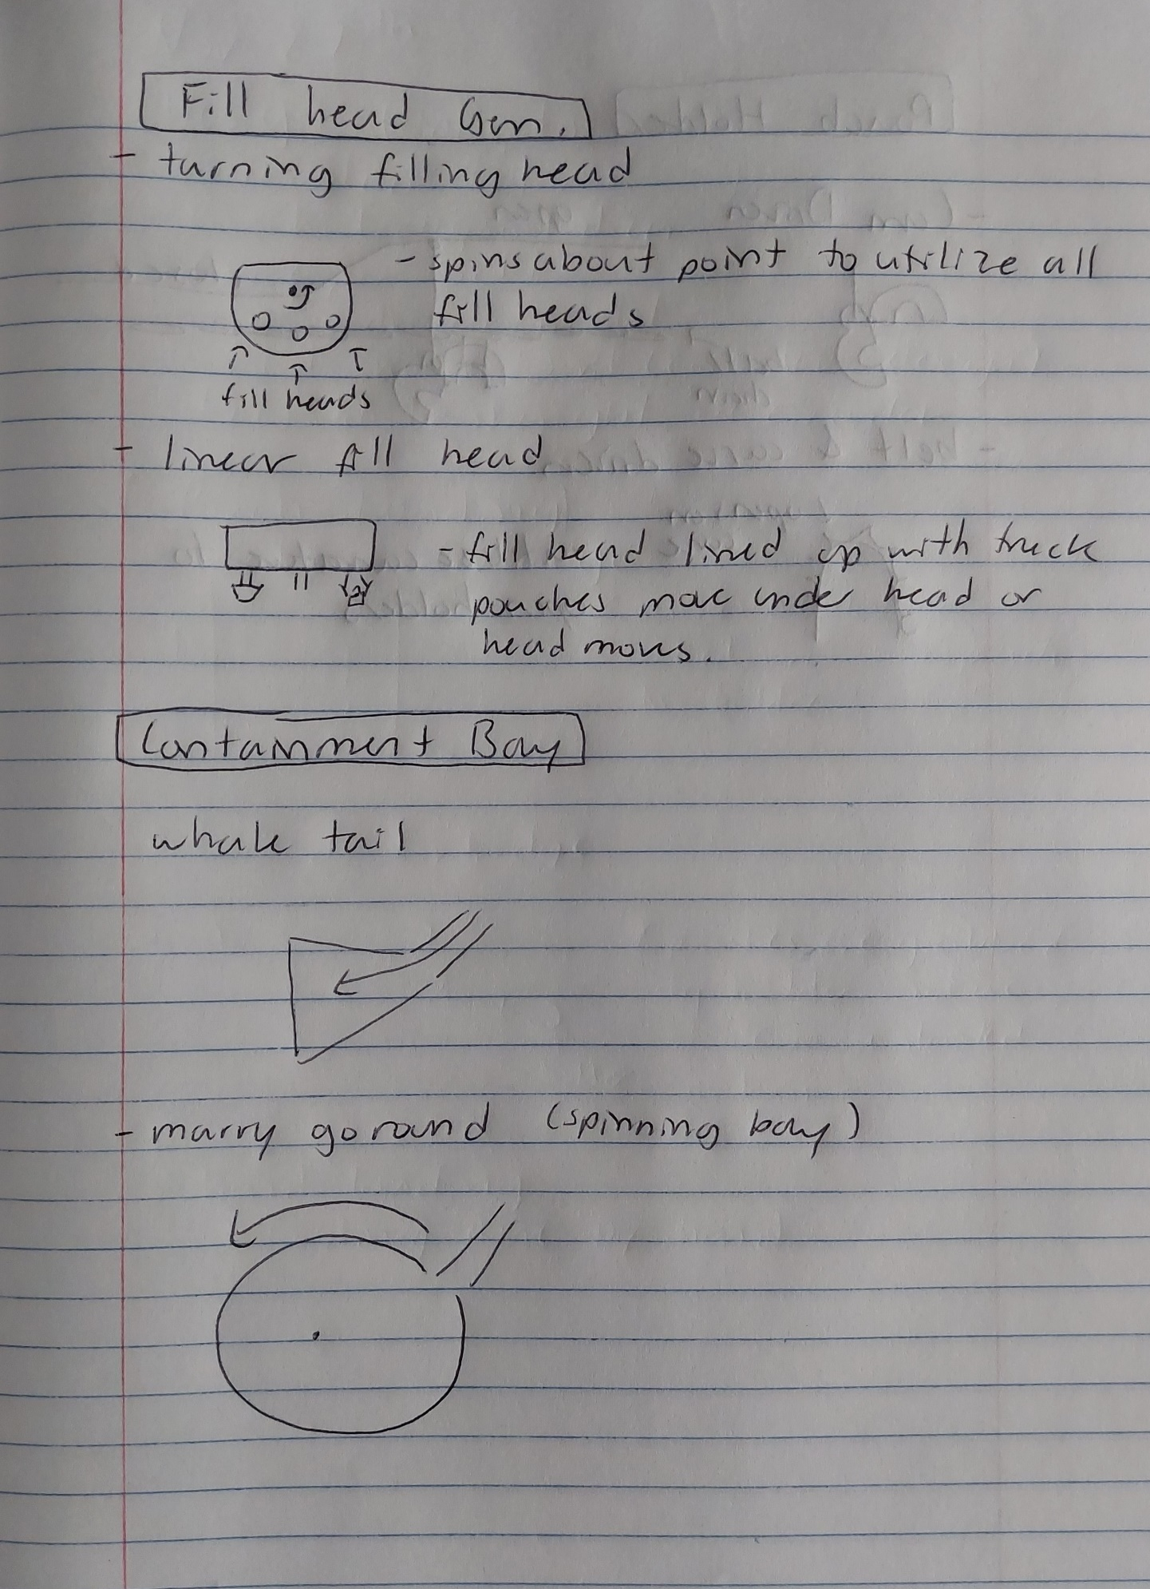

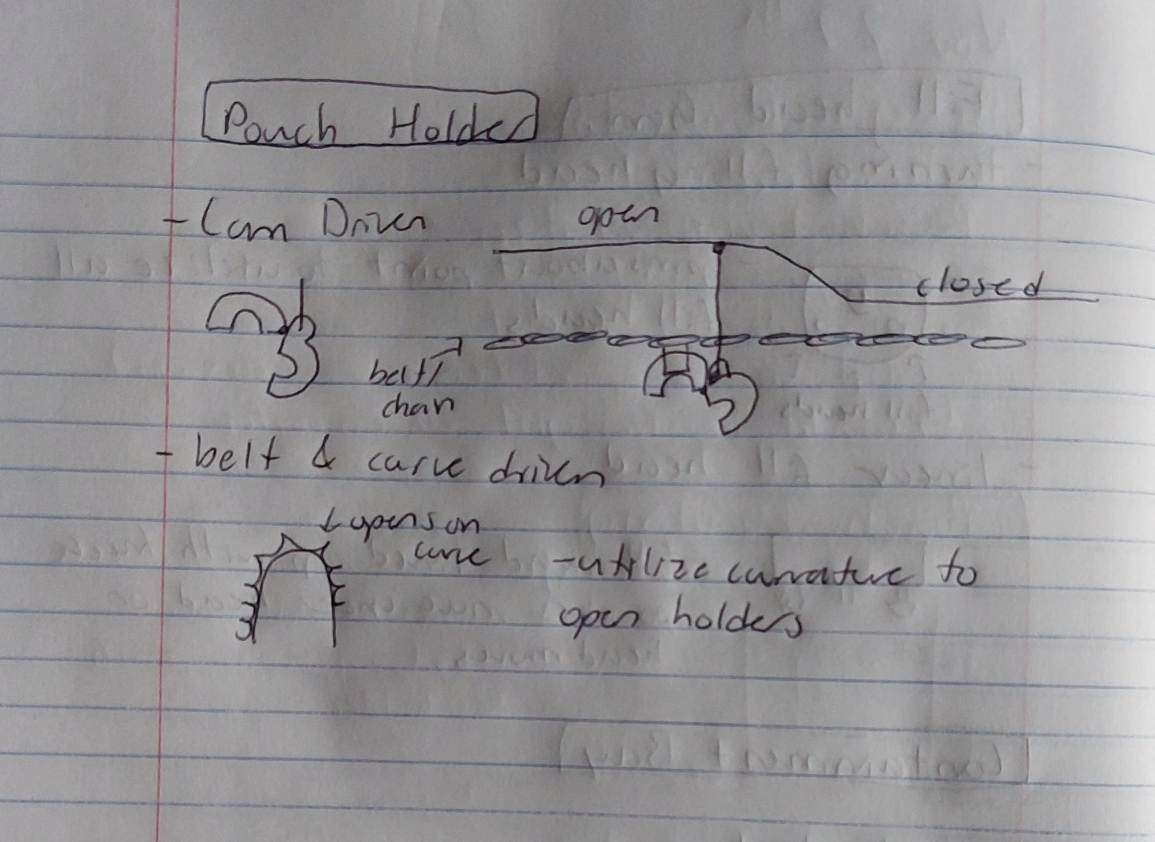

* **Milestone 1: Fill Head**
  + 1a. Separate tool heads
    - Caps are separate from pouches
    - Pros:
      * Does not require cap alignment
      * Tool heads only move on the z axis
      * Allows for production pipeline
    - Cons:
      * Requires more vertical actuators
      * Requires user to take off cap from pouch before loading
      * Requires that the caps be stored somehow to be later sealed on the pouch
  + 1b. Combined tool head
    - Linear vs Rotating
    - Caps attached to loaded pouches
    - Pros:
      * Singular vertical actuator needed
      * Less work for the user (don’t have to take cap off before loading)
    - Cons:
      * Only one operation can happen at a time
      * Must move in minimum of 2 axis (or 1 axis and 1 circle)
      * Requires cap alignment
* **Milestone 2: Cap Alignment/Feeder**
  + 2a. Vibration into form fit hole
    - Uses air or vibration to shake caps into form fit holes
    - Pros:
      * Cap may be picked up in any orientation
      * Cap may be on or off of pouch
    - Cons:
      * Relies on random processes
      * Possible jams
  + 2b. Rotating grabber
    - For cap on pouch
    - Attempts to grab the cap while rotating the clamp until the clamp is closed around the thinnest section of the cap
    - Pros:
      * Alignment is done before cap is grabbed
    - Cons:
      * Requires ability to measure clamp opening distance (complex)
      * Requires clamping actuation and rotation (2 degrees of freedom)
  + 2c. Separate Caps
    - For cap off pouch
    - Uses 2 rails for cap storage
    - Pros:
      * Does not require alignment
      * No additional degrees of freedom needed
    - Cons:
      * Can only be used with separate fill heads
      * User must place caps into storage device
* **Milestone 3: Pouch Movement**
  + 3a. Belt Fed
    - Uses a belt to advance pouches through the machine
    - Pros:
      * May use teeth or clamps (current securing method) to hold pouches
      * Straight lines for mounting
    - Cons:
      * More moving pieces
      * Slack in belt could be a source of error
  + 3b. Disk Fed (Merry-Go-Round)
    - Pouches secured to rotating disk
    - Pros:
      * Fixed positioning (using rotation)
      * Less moving parts
    - Cons:
      * Pouches must use clamps (current securing method) to be held in place
      * Design is circular (mounting is harder)
* **Milestone 4: Pouch Loading**
  + 4a. Manual
    - Pros:
      * Reduced complexity
    - Cons:
      * Less automated/Requires user interaction
  + 4b. Vertical Cartridge
    - Uses hook to grab pouches
    - Pros:
      * Compact
    - Cons:
      * Hook may catch/damage pouches
      * Pouches cannot have caps on
  + 4c. Slanted Cartridge
    - Uses roller to grab pouches
    - Pros:
      * Pouches can have caps or no caps
      * Rollers allow precise positioning
    - Cons:
      * Requires longer loading ramp